Reflection- Questions
Key Stage 2: 2003 Paper A
1.
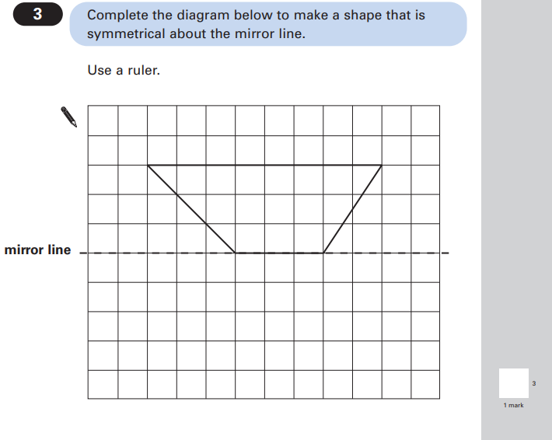

Key Stage 2: 2003 Paper B
1.
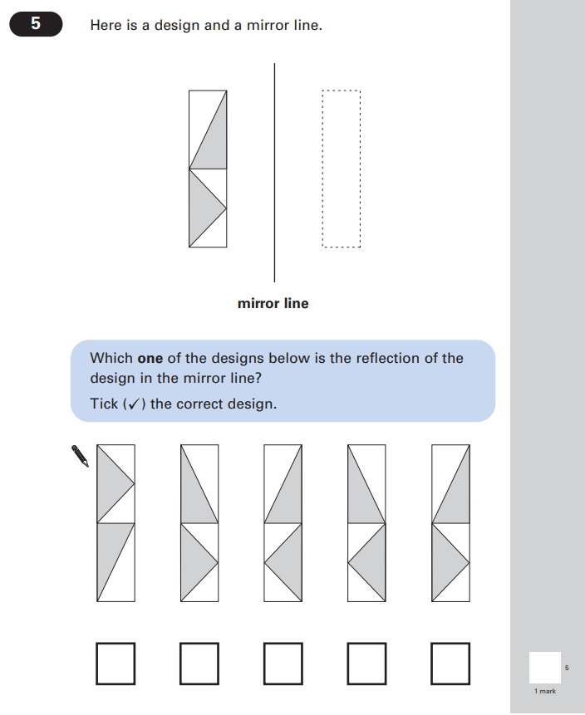

Key Stage 2: 2005 Paper B
1.
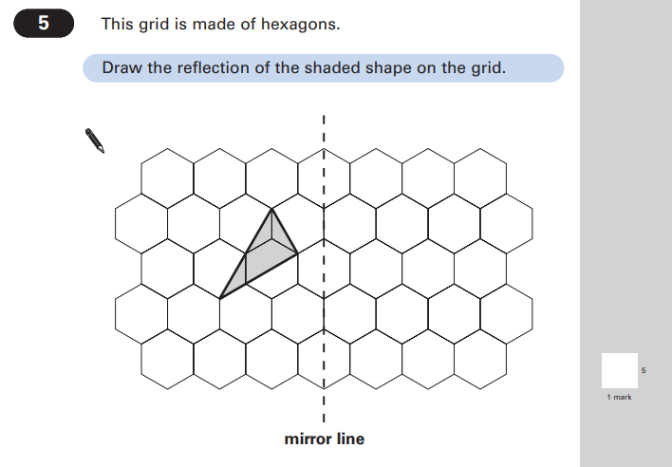

Key Stage 2: 2007 Paper B
1.
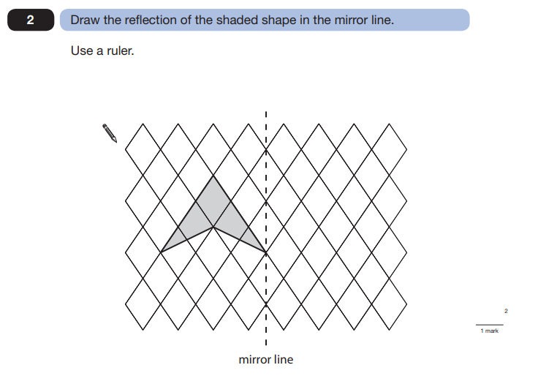

Key Stage 2: 2008 Paper A
1.
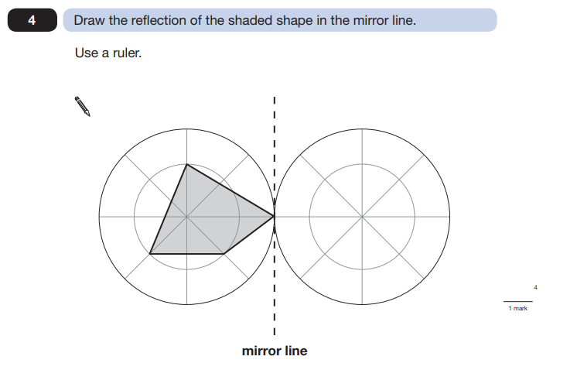

Key Stage 2: 2009 Paper A
1.
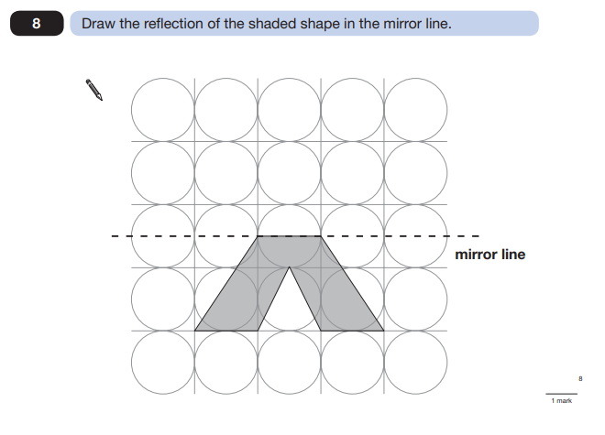
Key Stage 2: 2010 Paper B
1.
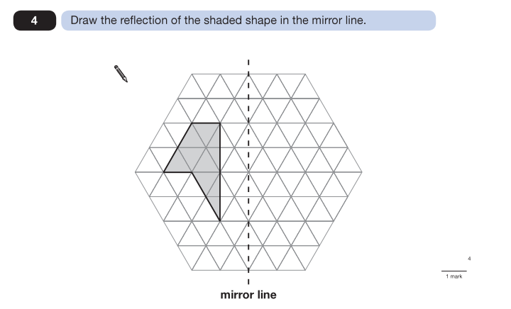
Key Stage 2: 2013 Paper A
1.
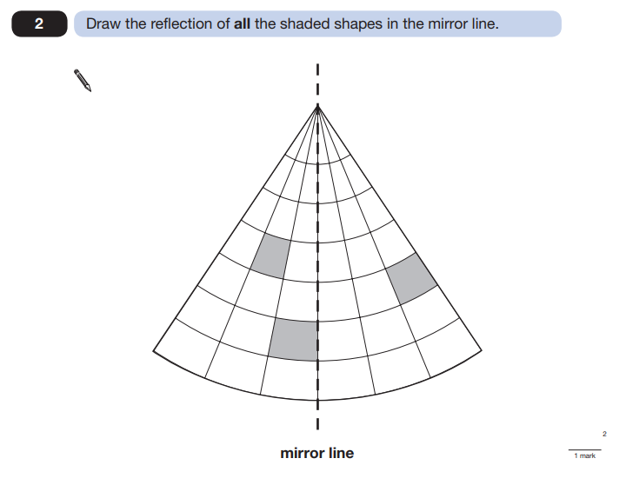

Key Stage 2: 2014 Paper B
1.
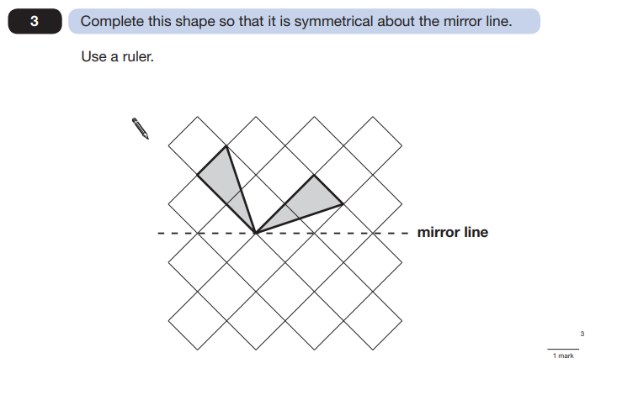

Key Stage 2: 2016 Paper 2 Reasoning
1.
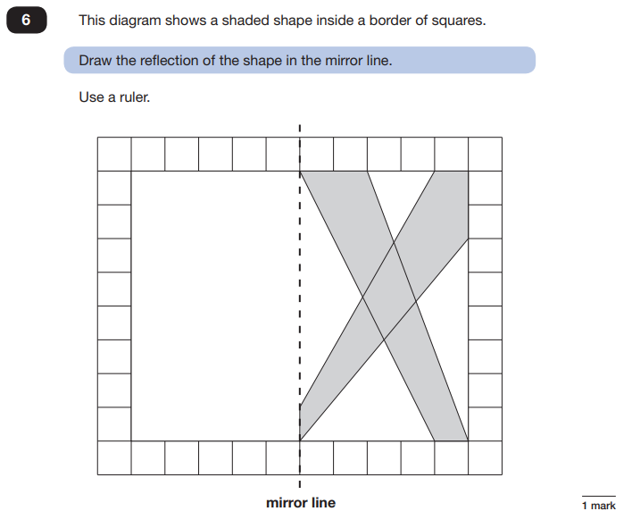

Key Stage 2: 2018 Paper 2 Reasoning
1.
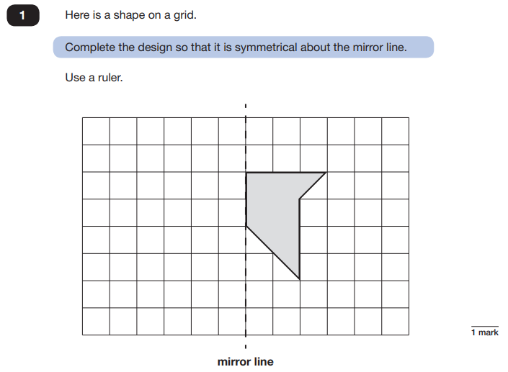

Key Stage 2: 2019 Paper 2 Reasoning
1.
